# **Health Danger Alert System**

***Submitted By:***

**G.Akhil**

**D.Chiranjevi Sai Venkat Kaushik**

**C.Ramkishan**

**G.Vivek**

**Table Of Contents**

**1.Introduction**

**2.Objectives of Research**

**3.Problem Statement**

**4.Data Collection**

**5.Methodology**

**6.Results and Experiments**

**7.Conclusion**

**1.INTRODUCTION**

Now-a-days people are facing many health issues. Due to this reason they have to take treatments for their health problems. So, the number of people admitted in hospital is increasing day by day.so any negligence by the hospital staff might lead to death of the patient.

In order to overcome this problem, we developed a Health Danger Alert System. The health danger alert system is an UI based artificial neural network model designed to alert the hospital staff when the condition of the patient is serious.

**2.Objectives of Research**

There have been many cases in the past where patients lost their lives as the hospital staff were unaware of the serious condition of the patient. Moreover, the patients cannot be under constant supervision all the time. So, in order to prevent this situation, we created Health Danger Alert System.

The Research on Artificial Neural Network has helped to create a Machine-Learning model named Health Danger Alert System in order to alert the hospital staff about the serious condition of the particular patient.

**3.Problem Statement**

A patient who is admitted in the hospital might get into serious condition when none of the hospital staff is around. In such cases, the hospital staff must be notified about the serious condition of the patient.

**4.Data Collection**

To analyse the serious condition of the patient, we considered few parameters like age, heartbeat, blood pressure (systolic, diastolic) and sugar level.

* For a healthy person the heartbeat varies from 49 to 73 and beyond that is an indication for serious condition.
* Similarly, the systolic varies from 90 to 120 and diastolic varies from 70 to 80 for a healthy person and any increase further may lead to serious condition.
* The sugar level varies from 80 to 180 and beyond that is an indication for serious condition.

So, considering all these parameter values we built a dataset to train the model.

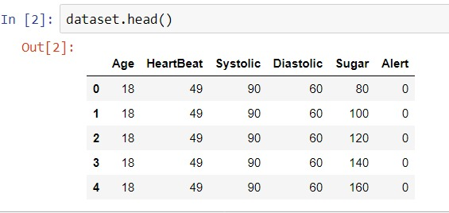

**5.Methodology**

**Backend:**

* First, we load the dataset into Watson-Studio and perform all the data pre-processing steps.
* Data pre-processing includes filling out missing values with mean or median or mode, followed by performing label encoding and one-hot encoding.
* Then we slice the dataset into independent and dependent variables.
* Then we split the dataset into training set and testing set by importing train_test_split library.
* We build a classification model using keras library.
* The classification model consists of input layer, hidden layers and output layer.
* Every unit in a layer is associated with some weight that ranges from 0 to 1.
* We add the layers by importing Dense library.
* Input layer is used for giving inputs to the model.
* We use random_uniform to assign initial weights uniformly in the input layer.
* We use “relu” activation function in the input layer.
* The number of input dimensions will be the number of parameters that we are passing to the model.
* Similarly, we add the hidden layer with same strategies as input layer.
* Since it is a binary classification, we use sigmoid activation function in the output layer.
* Then we train the model by running it for a number of epochs until we get the desired accuracy.
* While training the model, we use the batch gradient descent optimizer.
* Now we integrate with WatsonMachineLearning by using WatsonMachineLearningAPIClient library.
* After deploying the model, we generate scoring endpoint.

**Frontend:**

* To create the user interface, we node-red flow editor.
* We use a function that creates random values for the parameters to be passed to the model.
* We use http request to obtain the token by providing basic authentication.
* We use this obtained token to pass the parameter values to the model to make prediction.
* We use gauges for representing the parameter values.

**6.Results and Experiments**

* In the first picture,since all the parameter values indicate bad condition and hence the patient is not safe.
* In the second picture,since all the parameter values indicate good condition and hence the patient is safe.

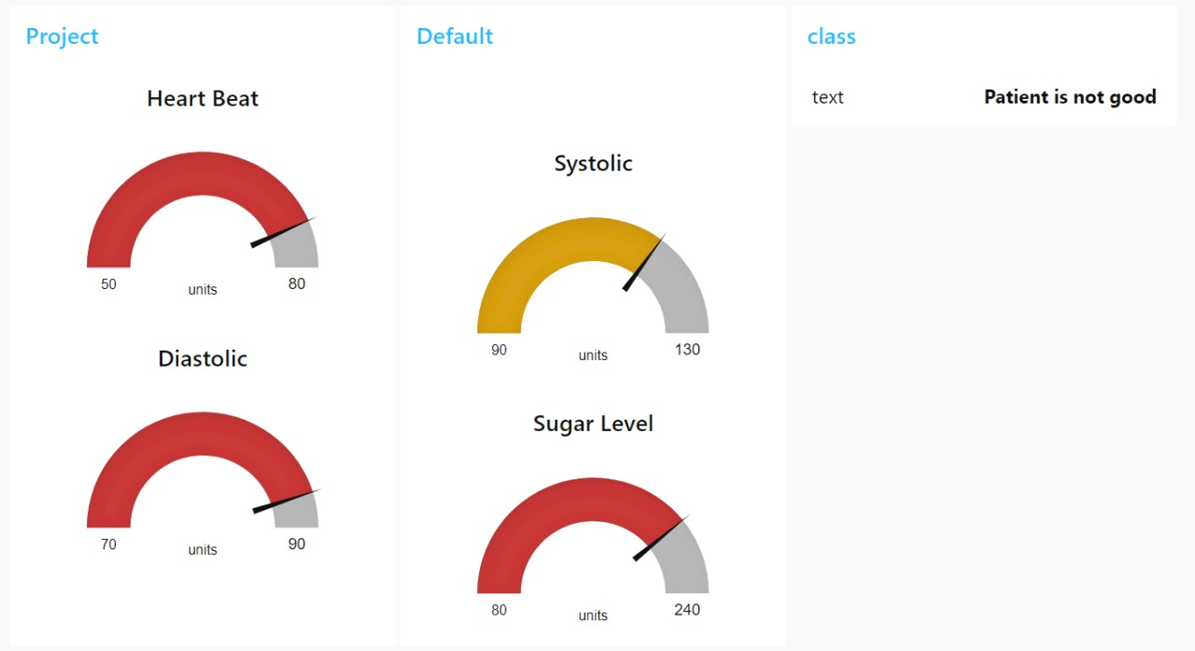

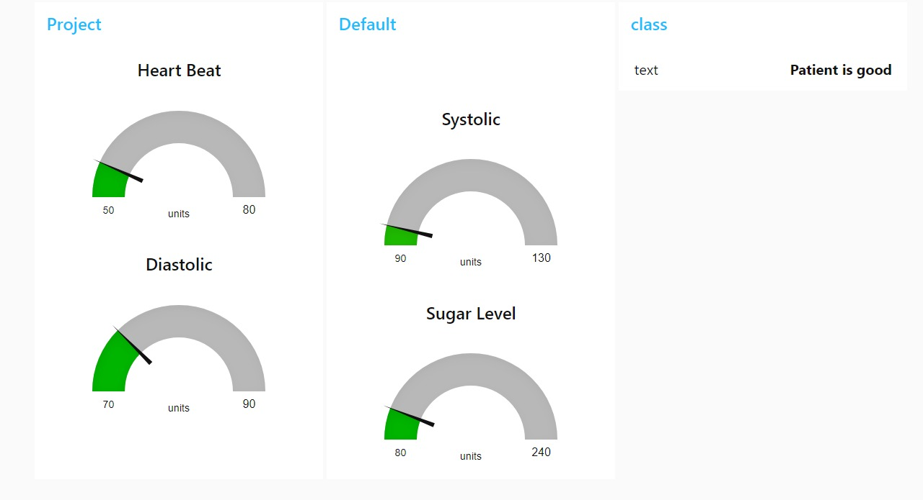

**7.Conclusion**

* So, the Health Danger Alert System can be integrated with the IOT devices and used in the hospitals to alert the hospital staff about the serious condition of the patient.
* The Health Danger Alert System is to be made mandatory in every hospital in order to protect the patients in ICU’s.